**Introduction:**

IPv6 is the next generation IP protocol to replace the current IPv4. IPv6 provides an expanded address space, and supports new Internet applications that require advanced features to provide services like real-time audio. However, IPv6 is still in its infancy and is rarely used. To qualify the IPv6 infrastructure, it is interesting to compare the IPv6 and IPv4 measurements under the current network situations.

This project consists in analyzing the path inflation between IPv4 and IPv6 paths in the Middle East Region(MENOG) which is known to have a poor deployment of IPv6 in comparison to Europe or USA.

**Methodology:**

In order to see the path inflation between IPv6 & IPv4, we will compare two criteria by using traceroute:

-the number of hops traversed by the packets

- the RTT of the packets

To do so, we used some Ripe Atlas probes that cover the MENOG region and work with ipv6 &ipv4 as sources of the traceroutes. We can list the probe’s sources: 2 probes from Lebanon, 2 probes from Iran, 3 probes from Turkey, 1 probe from Oman and one probe from Iraq. As for the destinations, we used some of the Ripe Atlas Anchors spread worldwide, we made sure to select anchors from each continent. The destinations Anchors that we chose are located in: Japan, South Africa, France, Kuwait, Uruguay, Montreal, Spain.

In order to get realistic results, we executed periodic traceroutes and calculate the average of the number of hops and RTT. The traceroutes are done every 3 hours from 2018-05-08 till 2018-06-01.

**Results:**

For the results, we have made 72 path measurements for IPv6 and 72 path measurements for IPv4 and after filtering the successful measurements the number dropped to 45 successful path measurements for IPv4 and for IPv6. In order to analyze the results, we have made a script that plot two histograms one that shows the percentage of the path measurements according to the difference in number of hopes between IPv4 and IPv6 and the other shows the percentage of the path measurements according to the difference in RTT between IPv4 and IPv6 packets. Note that we subtracted the IPv4 value from the IPv6, that means that the positives value on the x axis corresponds to an IPv6 hope or RTT value greater than the IPV4 value.

Figure 1:

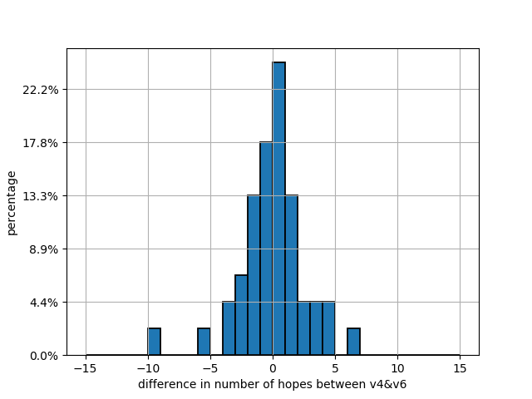

In figure 1 plotted on 12-5-2018, we can see that 25% of the measurements have the value of number of hopes equal in IPv4 and IPv6, 17.8% have the IPv6 value less than IPv4 by one hop,13.3% have the IPv6 value less than IPv4 by two hops and have the IPv6 value greater than the IPv4 by one hop, 7% have the IPv6 value less than IPv4 by three hops, 4.4% have the IPv6 value less than IPv4 by four hops and 4.4% have the IPv6 value greater than IPv4 by two and three and four, and finally 2.2 % have the IPv6 value less than IPv4 by six and ten hops, and 2.2% have the IPv6 value greater than IPv4 by two and 6 hops.

We can see that the number of hops in IPv6 is slightly fewer than with IPv4. We can conclude that the working IPv6 routers aren’t limited and isolated in certain locations because we obtained values very close to the IPv4 values and the maximum value in difference is 10 hops which is made by one of the path measurements, for the others the difference value is less than 5 hops.

Figure 2:

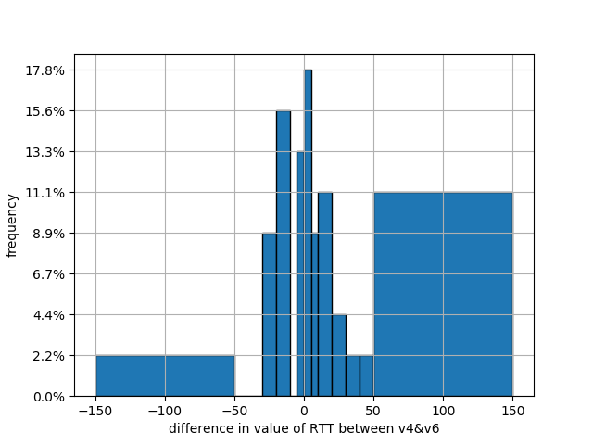

In figure 2 plotted on 12-5-2018, we are analyzing the difference in RTT value in order to compare the performance of the routing between IPv4 and IPv6.We can see that RTT value of IPV6 is higher than with IPv4 even though the packets traverse less hops. This can be interpreted either by the effect of tunneling that slower the process of routing or simply by the fact that the packets traverse a long distance than in IPv4 due to a fewer number of connections between routers from different regions. For example, maybe a packet destined to an African or American country must traverse first Europe because there isn’t a direct connection to the destined continent or region.

So in order to try to specify the cause of these results we will try to calculate the AS-path and geolocation of the measurements done from Lebanon. From seeing the AS-path we concluded that every path coming out from Lebanon pass by Level 3 which is obvious since Level 3 is a teer1 operator, and we saw that the AS-path is almost the same in IPv4 and IPv6.

For the geolocation script, we couldn’t establish results since the geolocation of ipv6 is not precise enough to obtain a conclusion.

Scripts:

Let’s talk about the functionality of the scripts published on GitHub:

test-probes.py is used to automatically make the periodic measurements from RIPE atlas.

test_measurements_periodic.py is used to calculate the average RTT and hops values for each measurement and plot the histograms.

stop_measurements.py is used to stop measurements

pyasn.py is used to calculate the AS path by using api.iptoasn.com API to map the IP to ASN for each hop traversed by the measurements done from Lebanon.

test_location.py is used to calculate the geolocation of each hop traversed by the measurements done from Lebanon.

Conclusion:

In conclusion, we could say that in the MENOG region the IPv4 have better RTT performance that in IPv6 but the length of the path is longer. It is due to either the effect tunneling or the distance traversed by the packets. We couldn’t specify the exact cause of the delay but it can be both. For further measurements, it seems interesting to study the effect tunneling of IPv6 in the MENOG region.